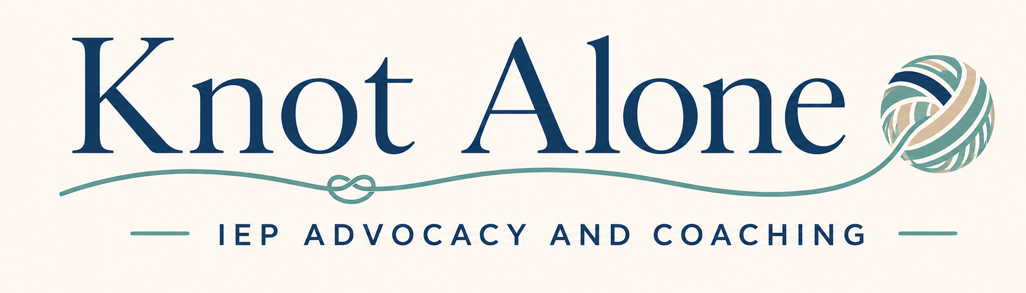
UNTANGLING SECTION 504 PLANS
A Parent-Friendly Guide to Eligibility, Functional Impact & Accommodations
Section 504 language can feel confusing. This guide explains eligibility, major life activities, functional impact, accommodations, and common terms in plain language so families can better understand how a disability may affect access and functioning at school.

How to use this guide: Start with '504 Essentials,' then use the major-life-activity and functional-impact sections to organize questions about how your child's impairment affects school and daily functioning.
Together, we untangle the path forward.

1. 504 Essentials
Common terms families may hear when discussing Section 504

Term / acronym | What it means / stands for | What it means for parents
504 | Section 504 Plan | A civil rights plan that provides accommodations for students with disabilities who may not qualify for an IEP.
ADA | Americans with Disabilities Act | A civil rights law that protects people with disabilities from discrimination.
OCR | U.S. Department of Education Office for Civil Rights. | The federal office that enforces Section 504 and investigates qualifying disability-discrimination complaints.
Accommodations | Accommodations | Changes in how your child learns or shows learning without changing what is expected.
AT | Assistive Technology | Tools or services that help your child access learning.
FERPA | Family Educational Rights and Privacy Act | The federal law that gives parents rights related to student education records.
Child Find | The school's duty to identify, locate, and evaluate children who may have disabilities. | Parents do not have to wait for a child to fail before raising concerns or requesting an evaluation.
Consent | A parent's informed written agreement to certain school actions. | Ask what you are agreeing to and what happens if you decline.

Key idea: A Section 504 plan is a civil rights plan. The guide focuses on access, functioning, and the supports a student may need because of a disability.

2. Eligibility, Major Life Activities & Functional Impact
Section 504 looks beyond grades to how an impairment affects everyday functioning and access to school

504 term | Parent-friendly definition | What it means for parents
Section 504 disability | A physical or mental impairment that substantially limits one or more major life activities. | A diagnosis alone does not automatically determine eligibility; the team reviews the individual student.
Major Life Activity | An important everyday activity or major bodily function. | Examples include learning, reading, concentrating, communicating, seeing, hearing, walking, eating, sleeping, breathing, and self-care.
Substantially Limits | The impairment meaningfully limits a major life activity compared with most people. | This is a broad, individualized standard; there is no single required score or percentage.
Functional Impact | The real-world effect of an impairment on how a student functions at school and in daily activities. | Impact is not limited to grades. Attention, communication, mobility, stamina, self-care, or health functions can matter.

Key idea: Learning is only one major life activity. A Section 504 team should consider every major life activity or major bodily function affected by the impairment.

2. Eligibility & Functional Impact (continued)
Key concepts that help teams evaluate disability broadly and individually

504 term | Parent-friendly definition | What it means for parents
Mitigating Measures | Things that reduce the effects of an impairment, such as medication, devices, strategies, or accommodations. | Eligibility is generally considered without the helpful effects of these measures; ordinary eyeglasses are treated differently.
Episodic / In Remission | A condition whose symptoms come and go or are not currently active. | It can still qualify if it would substantially limit a major life activity when active.
504 Plan / Service Agreement | A written plan describing accommodations, aids, services, or supports needed under Section 504. | The plan should match the student's individual functional needs and be reviewed when needs change.

Parent tip: A student may earn strong grades and still be substantially limited in a major life activity. Ask the team to consider the effort, time, fatigue, symptoms, or supports required for the student to function successfully.

3. Major Life Activities: School-Based Examples
How common major life activities may affect access, participation, and functioning at school

Major life activity | What it can involve | Examples of school-based impact
Learning / Reading | Learning new information, decoding, comprehension, or reading efficiently. | Impact may show up as extra time, effort, fatigue, or need for supports even when grades are strong.
Concentrating / Thinking | Sustaining attention, remembering, processing, planning, organizing, or problem-solving. | Impact may appear in task completion, multi-step directions, distractions, or inconsistent performance.
Speaking / Communicating | Expressing ideas, understanding language, participating, or using a communication system. | Impact may affect asking for help, discussions, presentations, peer interaction, or access to instruction.
Seeing / Hearing | Using vision or hearing to obtain information and navigate the environment. | Impact may affect print, board work, videos, teacher speech, discussion, announcements, or safety information.

Parent tip: Describe what the child has to do to function successfully: extra effort, more time, frequent prompting, breaks, medication, adult help, or missed school can all help explain functional impact.

3. Major Life Activities (continued)
Physical, self-care, health, and bodily-function examples are also important under Section 504

Major life activity | What it can involve | Examples of school-based impact
Walking / Standing / Manual Tasks | Moving, changing position, writing, lifting, bending, or manipulating materials. | Impact may affect transitions, handwriting, carrying materials, physical education, fatigue, or adaptive equipment.
Eating / Sleeping / Breathing / Self-Care | Daily functions such as eating, sleep, breathing, toileting, dressing, or managing health needs. | Impact may affect attendance, stamina, concentration, breaks, bathroom access, meals, or emergency supports.
Major Bodily Functions | Internal functions such as neurological/brain, digestive, bowel, bladder, respiratory, circulatory, endocrine, and immune functions. | A student can be substantially limited in a bodily function even when the condition is not obvious in class.

Reminder: Major life activities are not limited to this list. Section 504 eligibility is individualized and should consider all relevant school, medical, family, and evaluation information.

4. Accommodations, Access & Helpful Support Terms
Common words parents may hear when discussing how a student accesses school

Term / acronym | What it means / stands for | Parent-friendly definition
Accommodations | Accommodations | Changes in how your child learns or shows learning without changing what is expected.
AT | Assistive Technology | Tools or services that help your child access learning.
OT | Occupational Therapy | Services that may help with handwriting, fine-motor skills, sensory needs, and school tasks.
PT | Physical Therapy | Services that may support gross-motor skills, mobility, and physical access.
SLP | Speech-Language Pathologist | A provider who supports speech, language, and communication.
UDL | Universal Design for Learning. | An instructional framework offering multiple ways to engage, access information, and show learning.

Quick reminder: Accommodations change how a student accesses learning or shows learning without changing what is expected.

5. Other Helpful 504 Vocabulary
Rights, records, testing, behavior, and school-wide support terms

Acronym / term | What it stands for | What it means for parents
OCR | U.S. Department of Education Office for Civil Rights. | The federal office that enforces Section 504 and investigates qualifying disability-discrimination complaints.
ADA | Americans with Disabilities Act | A civil rights law that protects people with disabilities from discrimination.
FERPA | Family Educational Rights and Privacy Act | The federal law that gives parents rights related to student education records.
PSSA | Pennsylvania System of School Assessment | Pennsylvania's state tests.
Keystone | Keystone Exams | Pennsylvania end-of-course assessments used in some subjects.
FBA | Functional Behavioral Assessment | A process for figuring out why a behavior is happening and what may help.
BIP | Behavior Intervention Plan | A plan that describes strategies and supports to address behavior.
PBIS | Positive Behavioral Interventions and Supports | A framework focused on teaching and reinforcing positive behavior.

Parent tip: Use the functional-impact sections of this guide to connect concerns to specific school activities, participation, health needs, communication, attention, mobility, self-care, or other major life activities.

6. Fast Lookup Page
A quick alphabetical list of common Section 504-related terms

Quick lookup | Quick lookup
504 — Section 504 Plan | ADA — Americans with Disabilities Act
AT — Assistive Technology | BIP — Behavior Intervention Plan
Child Find — Duty to identify, locate, and evaluate | Consent — Parent informed written agreement
FBA — Functional Behavioral Assessment | FERPA — Family Educational Rights and Privacy Act
Functional Impact — Real-world effect on functioning | Major Life Activity — Important everyday activity or bodily function
Mitigating Measures — Things that reduce impairment effects | OCR — Office for Civil Rights
OT — Occupational Therapy | PBIS — Positive Behavioral Interventions and Supports
PT — Physical Therapy | PSSA — Pennsylvania System of School Assessment
SLP — Speech-Language Pathologist | Substantially Limits — Meaningfully limits a major life activity
UDL — Universal Design for Learning | 504 Plan / Service Agreement — Written accommodations, aids, services, or supports

Need more than a glossary? If you want help understanding a Section 504 plan, evaluation report, meeting notice, or school proposal, Knot Alone can help you review the documents and identify next steps.
Knot Alone IEP Advocacy & Coaching
Together, we untangle the path forward.

